Automated Labeling and Prediction of Future Growth in Emerging Consumer Packaged Goods
Drew Nunnally1, Devin Streeter1, Kristin Henderson1, Bivin Sadler1
1 Master of Science in Data Science, Southern Methodist University,
Dallas, TX 75275 USA
{dnunnally, dstreeter, hendersonk, bsadler}@smu.edu
Abstract. Spirits brokers and distributors need a reproducible way to identify brands that may achieve sales growth in the future. This study develops a proposed screening approach that combines automated outcome labeling with a prediction model. Observations are aggregated to brand-extension sales volume totals in consecutive 52-week periods. Growth from the first to the second period supplies the initial predictor, while growth from the second to the third period defines the binary outcome. A positive label is assigned when subsequent growth exceeds 40%, a threshold to be examined through sensitivity analysis and stakeholder discussion. The proposed output is a probability of exceeding the sales-growth threshold. [Results and conclusion]
1 Introduction
Evaluating an emerging consumer-packaged-goods brand requires a decision before its long-term performance is known. Sales history may show growth without establishing whether that growth will persist and provide little evidence of consistent future performance. In a study of 36,994 new line extensions, Victory et al. found that 72% had a market share below their category average in the quarter after launch, compared to approximately 66% three years later [1]. These results concern the categories and markets examined in that study rather than specifically spirits. However, they illustrate why the definition and timing of product success matters when translating observed sales into a decision.
The setting for this project is an industry partner’s interest in identifying spirits brands that merit further business consideration. The analytical task is to screen brand extensions for future case-sales growth using information available at a defined decision date. A brand extension is the unit formed by aggregating the relevant product-level observations under the extension identifier in the supplied data. It may represent only part of a brand family. An extension’s predicted sales growth cannot by itself establish the value of a business, the attractiveness of an acquisition, or the return on that investment.
Henderson and Sadler developed a framework for evaluating emerging consumer-packaged-goods brands using demand-based features and a multi-criteria decision analysis opportunity score [2]. Their study trained and evaluated models with a hand-labeled set of 112 brands in one subcategory and examined a separate stakeholder-provided set of 18 brand families. On the hand-labeled task, binary logistic regression achieved approximately 84% balanced accuracy while the opportunity score achieved up to 85%. The ordinal model’s 93% adjacent accuracy counted predictions within one ordered tier of the assigned label. These results support further investigation of simple demand features, while the lower external validation also indicates that results depend on the evaluation population and outcome definition [2].
This study builds on that use of demand information by focusing on a forward-looking outcome. Rather than assigning the previous study’s discontinued, decline, stable, and growing tiers, the proposed workflow labels whether an extension exceeds a chose sale-growth threshold during a subsequent period. The task can be applied repeatedly to eligible historical windows without manually interpreting sales trajectory. Its scientific question is whether the earlier growth pattern contains useful information about this later outcome. The reliability of the calculation and the usefulness of the business definition remains a separate question.
Retail prediction research makes clear that the unit of analysis and the decision being supported shape the modeling problem. Fildes et al. distinguish forecasts across product and organizational levels and review the effects on promotion, limited histories, and hetero generous demand patters [3]. In beverage alcohol distribution, Arora et al. found substantial improvements over naïve forecasts for selected products but also found that successful models required product-specific tuning [4]. Jiang et al. likewise reported forecast improvements for several product-customer combination, with performance varying by series and method [5]. Ford et al. developed an automated framework that selected among models for individual product-consumer combinations [6]. These studies motivate benchmarks and careful evaluation, they do not establish in advance that classification will outperform forecasting.
Classification offers a useful way to express the narrower screening decision in this projects. A probability of exceeding a defined growth threshold may help prioritize further examination when reviewing every extension in detail is not practical. Hirche et al. provide a related example of classifying retail performance, their models distinguish underperforming, in-line, and overperforming SKUs relative to the distribution-market-share relationship [7]. Their outcome, data structure and time frame differ from those proposed here. The connection is the use of an explicit performance definition to turn a broad managerial question into a measurable analytical task.
For the initial proof of concept, the decision date falls at the end of the second of three consecutive 52-week periods. The model receives growth from the first period to the second and predicts whether growth from the second period to the third exceeds the specified threshold. This makes the information boundary visible. Future growth constructs the retrospective label but is unavailable to the model at the decision date.
This design also narrows what the study can claim. Two input periods are required, so the baseline does not evaluate a brand at launch or solve predictions without sales history. Filtering for continued selling in the outcome year may remove declining or discontinued extensions, while very small initial volumes can produce extreme percentage changes. The eligible population, treatment of missing observations, and distribution of positive labels need to be examined before reporting predictive performance. The preliminary data audit provides a starting point for this examination, but its period rule differs from the current labeling prototype.
The research question is whether growth observed before a decision date can improve prediction of a subsequent sales growth threshold relative to simple screening baselines. The proposed contribution is a reproducible target definition and an evaluation that preserves the timing of available information. An operational dashboard may later expose the growth threshold and prediction cutoff for stakeholder exploration. Its usefulness will depend on validated predictions and an agreed interpretation of the outcome rather than the interface alone.

2 Literature Review

2.1 Defining performance for brand screening

Product success can refer to survival, market capture, volume growth, relative performance, or a financial outcome. These measures sometimes overlap but are not interchangeable. Victory et al. examines multiple methods of new-line-extension performance and show why a single average can conceal a skewed distribution [1]. Their mean market share of 0.3% should not be interpreted as a representation of every new product. The same study’s failure statistics also require attention to seasonal products. For this project, that evidence supports specifying the outcome and observation period before choosing the model.
Henderson and Sadler use trajectory-based tiers to evaluate brand opportunity and compare an opportunity score with binary and ordinal models [2]. Hirche et al. instead define performance relative to a distribution-market-share curve and report approximately 83% correct classification across three SKU-performance classes in their study [7]. Both approaches translate business performance into a structured target, but neither defines success as exceeding the future growth threshold. Their reported accuracy provides context rather than directly comparable performance targets.
Distribution and category conditions add complications to interpretation of growth. Michis estimates a semiparametric sales-response model and finds nonlinear distribution relationships that are often concave [8]. Bronnenberg and Simeiro show how retail structure and geographic relationships can inform predictions for markets with limited data [9]. Dunn et al. analyze revenue changes across consumer-packaged-goods categories and identify category penetration and price per volume as major growth components [10]. Together, these studies suggest that growth can reflect changes in the surrounding market as well as extension-specific demand. They justify examining category differences and acknowledging omitted context even when the first model intentionally uses one predictor.

2.2 Forecasting evidence and simple baselines

The retail forecasting review by Fildes et al. describes problems that vary with aggregation level, and available explanatory variables and the decision horizon [3]. These are relevant because this project aggregates weekly product observations to extension-level annual case totals. Annual aggregation provides comparable seasonal windows and reduces the number of observations needed to define the target but also removes within-year timing information. A model based on annual growth cannot be interpreted as predicting weekly inventory demand or the timing of a sales peak.
The alcohol-distribution studies offer examples of heterogeneous results. Aro et al developed ensemble approaches and report forecast-error reductions for the products studied [4]. Juang et al. compared time-series and deep-learning models with naïve models for vodka product-customer combinations and find that the preferred model is not uniform across combinations [5]. Ford et al. responds to this variation with automated model selection and explicit checks of the time series being modeled [6]. The common implication for the present study is to demonstrate added value against a transparent baseline, rather than assuming that a fitted model is useful.
Ulrich et al. formulates retail forecast-model selection as a classification problem, assigning classes according to which forecasting method performs best under the chosen objective [11]. Their evaluation considers economic profitability through shortage and inventory costs. This is a different decision from selecting a brand for investment, but it shows why an evaluation criterion should follow the intended use. In the present study, a false positive means predicting that an extension will exceed the sales-growth threshold when it does not. It does not directly quantify money lost on an investment. Financial consequences require specified costs, margins, and decision rules.

2.3 Automated labels and learning across products

Automated labels make a supervised task reproducible only when their meaning and limitations are explicit. Lam et al. studies programmatic labeling through functions that produce weak labels, with attention to coverage, reliability and downstream classification quality [12]. Their Expona framework is evaluated on text-classification tasks and combines multiple heuristic labeling functions. This study’s output is simpler, calculating an observed future-sales ration and applies a deterministic threshold. The connection is the need to evaluate label coverage and validity separately from performance of a model trained on those labels.
The threshold label is a reproducible statement about whether a specified growth occurred. Its interpretation as an attractive investment remains a business hypothesis. A model can predict that rule well, even when the rule does not represent the stakeholder’s preferred decision. However, low predictive performance may indicate that earlier growth is not sufficient, not that the rule was calculated incorrectly. This is important when comparing a new binary outcome with Henderson and Sadler’s manually assigned tiers [2].
Research on learning across products offers potential extensions if separate category models have limited data. Zhu et al. use cross-series training and supply chain information in pharmaceutical demand forecasting [13]. Lei et al. develop a transfer-learning approach that combines category-level and product-level information for retail demand prediction [14]. These studies show ways to share information, but their forecasting methods and industry settings differ from a one-predictor growth classifier. The initial pooled logistic model should therefore be evaluated on its own terms. More complex pooling or category-specific models are later comparisons, depending on sample size and evidence of heterogeneous relationships.

2.4 Automated labels and learning across products

External information may capture factors absent from historical sales. Kumar et al. combines historical supermarket demand with news and Google Trends information in a multimodal forecasting model [15]. Pozner et al. examines how audience growth changes craft-beer evaluations and penalties associated with authenticity violations [16]. These studies are focused on demand forecasts and consumer rating, and do not validate acquisition recommendations. They identify possible influences outside of the current dataset while also showing why adding information would require a separate data collection and evaluation effort.
Literature supports a focused first experiment with bounded claims. The proposed hypothesis is that prior-year sales growth contains enough information to improve future-growth screening over majority-class baselines. The hypothesis evaluated using a common label, sample and held-out period. Category differences, label prevalence, and the effect of sample restrictions will be examined alongside predictive performance. Claims that the resulting output probabilities identify attractive investments will require further validation and financial information.

3 Data

3.1 Data Source and Preparation

The industry partner supplied NIQ liquor scanner data under a nondisclosure agreement. The raw feed contains approximately 77 million rows across product categories and market definitions, with weekly observations from late January 2021 through early January 2026. The filtered data contains 7,334,190 UPC-week rows, exactly the number in the prepared file used by Henderson and Sadler. We then verified that our independent preparation selected the same records. The rows describe 22,495 brand extensions in 11 categories. To protect the confidentiality of the partner's data, categories are reported under letter codes, Category A through Category K, assigned in order of total case volume over the five years.

3.2 Weekly Brand Measures

For each brand extension and week, we computed total cases across its UPCs. Weeks before a brand’s first appearance are treated as missing, while weeks after it with no record are treated as zero sales and zero coverage. The unit of analysis is the brand extension.

3.3 Year-Ends

The 260 weeks form five consecutive 52-week years that do not align with calendar years. Labels are assigned at the end of each year that has prior data for a full year available, resulting in four year-ends (Table 1). Throughout the paper a year refers to the 52-week year that ends in January of the following calendar year.

Table 1. Year-ends at which brands are labeled. Week 1 ends January 23, 2021.
Year | Last week | Week ending | Brands labeled
2022 | 104 | Jan 14, 2023 | 16,918
2023 | 156 | Jan 13, 2024 | 18,944
2024 | 208 | Jan 11, 2025 | 20,513
2025 | 260 | Jan 10, 2026 | 21,720

3.4 Market Context

Figure 1 shows weekly cases sales by category. Category A and B are the largest by volume and gradually trend downward over the five years, with Category B and F peaking during the holiday season. Category C shows summer peaks that grow each year and exceed Category A and B at the 2024 and 2025 summer peaks. Category D rose steadily. Strong seasonality in some categories is a risk for rules that compare recent weeks with the brand’s best weeks.

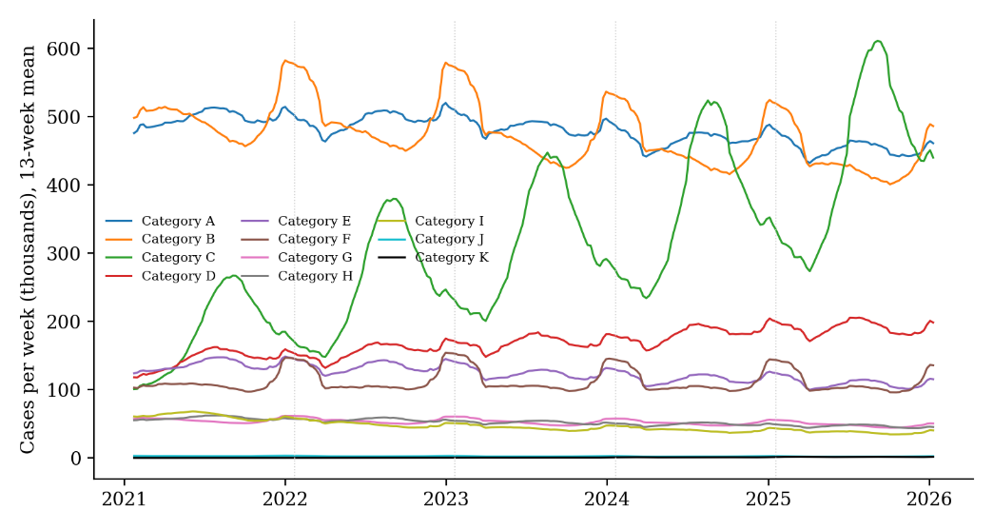
Fig. 1. Weekly case sales by spirits category, Total US Liquor Open State, January 2021 to January 2026, shown as a 13-week rolling mean.

4 Methods

There are two stages to the methods. An automated labeler assigns each brand to one of the expert’s four tiers at year-end. Prediction models then use what was known at the one year-end to predict the label of the next.

4.1 Automated Labeling Rules

Henderson and Sadler labeled brands by viewing 13-week moving averages of cases and %ACV with emphasis on the most recent two years [2]. We translated that visual judgement into three ratios computed for each brand using only weeks up the year-end:

- Sales vs. Best: average weekly cases over the last 13 weeks divided by the highest 13-week average the brand has ever reached.
- Stores vs. Best: the same ratio for %ACV, measuring how much of the peak distribution is retained.
- Store trend: average %ACV over the last 52 weeks divided by the average over the 52 weeks before.

Each ratio compares a brand with itself rather than on a fixed volume. Four rules, applied assign the tier (Table 2). Brands with fewer than 52 weeks of history at a year-end are not labeled, following the original study. When a brand has no prior-year coverage, the store trend is treated as flat.
Table 2. Labeling rules, applied in order. The first rule that matches assigns the tier.
Order | Tier | Rule
1 | Discontinued | Sales vs best < 10% and stores vs best < 10%
2 | Growing | Sales vs best ≥ 80% and store trend ≥ 1.03
3 | Decline | Store trend < 0.90 or stores vs best < 40%
4 | Stable | All remaining brands

These labels were simplified into a binary target, while still following the original study. Stable and growing brands are viable (1), and declining and discontinued brands are low performing (0). Every label is stored with a plain-language reason so that an analyst can see why each brand received its tier. The rule thresholds were set by examining the expert-labeled brands.

4.2 Validation Against Expert Labels

The only human labels available are the 112 single-extension brands labeled by Henderson and Sadler. We applied the rules to the same brands as of the same year-end and compared the results in two ways: agreement across the four tiers and agreement on the binary split. Because the thresholds were set using these same brands, this comparison measures how the rules reproduce the expert on the data used to build them. This test is not independent, as no human labels exists for earlier year-ends or for other categories.

4.3 Consistency Across Categories

Instead of a second hand-labeled set, two checks examine whether the rules behave consistently when applied to categories they were not tuned on. The first compares distribution of tiers across categories at the end of the final year-end. The second addresses seasonality. Because the rules compare the last 13 weeks with the best 13 weeks, a summer-peaking category could appear far from its best every January. We relabeled every brand as of July 2025 and measured the share of brands whose label changed in each category. Similar change rates across categories indicate that the rules respond to brands rather than the season. Chart examination of a randomly chosen sample of brands per category supplemented both checks.

4.4 Prediction Task and Models

Each prediction row pairs a brand’s input at one year-end with its label at the next. The two targets modeled are: Viable next year and growing next year. Survival was identified as the priority by our industry partner, with growth being secondary. Inputs are the three labeling ratios, current %ACV, brand size, the log of cases over the last year, brand age, sales growth, cases over the last year divided by the year before, momentum, indicators for the current tier, category, and price tier. Growth ratios are capped at 5 so that the fit is not dominated by growth of smaller brands.
Only brands that sold at least 250 cases (about five per week), in the year before the prediction are included. The floor is provisional. We fit a logistic regression on standardized inputs and a gradient boosting classifier. Both used balanced class weights so that the probability cutoff of 0.5 is meaningful despite unequal class sizes. Logistic regression was chosen for its interpretable coefficients and gradient boosting to capture interactions.

4.5 Evaluation Design and Metrics

Models are trained on the transition from 2022 to 2023 and from 2023 to 2024 and tested on the transition from 2024 to 2025. All inputs for a test row are measured at the end of 2024 and its outcome at the end of 2025 so that no information from after the prediction date enters the inputs [17], and a held-out transition is the most recent available [18]. Brands may appear in several transitions.
Two baselines are evaluated on the same test rows. The first assumes no change, the second is logistic regression on prior-year sales growth. Results are reported as the hit rate among 100 and 500 brands that each method ranks the highest, balanced accuracy at a 0.5 cutoff, and AUC. The top-100 hit rate is the primary measure because it matches a short list to be reviewed by an analyst [19]. To see which inputs drive each model, we report logistic coefficients and permutation importance for gradient boosting.
All analysis was conducted in Python with pandas, PyArrow, and scikit-learn using fixed random seeds. Data remains on local machines in accordance with the nondisclosure agreement with reported results as aggregates.

5 Results

5.1 Agreement With Expert Labels

Table 3 compares the automated labels with the expert’s labels for the 112 hand-labeled brands. The rules assigned the same tier to 101 brands (90.2%). There was complete agreement for the growing brands and near complete agreement for the discontinued brands. The lowest agreement was for stable brands, which the rules occasionally placed in the tier above or below. On the binary split, the rules agreed 107 of 112 (95.5%) times, with a balanced accuracy of 95.4%. Of the 11 tier disagreements, six were between tiers on the same side of the binary split and five were not.
Table 3. Expert labels (rows) versus automated labels (columns), 112 single-extension brands, end of 2025.
Expert label | Discontinued | Decline | Stable | Growing | Agreement
Discontinued | 28 | 0 | 1 | 0 | 96.6%
Decline | 4 | 26 | 0 | 0 | 86.7%
Stable | 0 | 4 | 22 | 2 | 78.6%
Growing | 0 | 0 | 0 | 25 | 100.0%
All brands |  |  |  |  | 90.2%

We do not compare these figures to the 84-85% balanced accuracy of the original models [2]. The task of those models was to predict demand features while our rules imitate the expert directly.

5.2 Labels Across Years and Categories

Applied to the full market, the rules produced 78,095 brand-year labels. The number of labeled brands rose from 16,918 at the end of 2022 to 21,720 at the end of 2025 as younger brands reached a full year of history. Over the same period the share labeled viable fell from 36.4% to 21.2%, and the share of brands labeled growing fell from 12.6% to 5.1%.
Figure 2 shows the tier mix by category at the end of 2025. The nine largest categories have similar splits: 35% to 51% discontinued, 29% to 40% decline, 14% to 20% stable, and 4% to 8% growing, with 17% to 26% labeled as viable. Categories J and K show the largest change in distribution with more than half of their brands being viable, but they are the lowest represented categories.
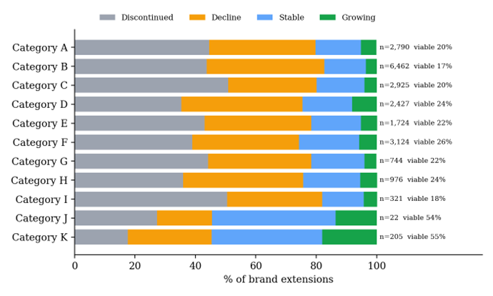Fig. 2. Automated label mix by category at the end of 2025. Labels give the number of labeled brand extensions and the share viable (stable or growing).

The seasonality check did not find category specific bias among the ten categories with stable histories as seen in Table 4. Between July 2025 and January 2026, 23.5% to 30% of brands changed tier and 9.1% to 14.4% changed binary level. Category C, the most seasonal category seen in Figure 1, changed 30%. Category K changed to 46.4%, well above the rest of the categories. This may reflect brands establishing their peak rather than seasonal distortion, but the check cannot distinguish this.
Table 4. Share of brands whose label changed between July 2025 and January 2026, by category.
Category | Brands | Tier changed | Viable label changed
A | 2,753 | 26.8% | 10.8%
B | 6,230 | 23.5% | 10.4%
C | 2,807 | 30.0% | 11.1%
D | 2,336 | 26.0% | 10.9%
E | 1,701 | 27.6% | 11.3%
F | 3,080 | 27.5% | 12.4%
G | 730 | 27.8% | 14.4%
H | 961 | 29.0% | 11.7%
I | 319 | 25.4% | 12.5%
J | 22 | 27.3% | 9.1%
K | 181 | 46.4% | 14.4%

5.3 How Labels Change from Year to Year

Table 5 shows how brands move between tiers from one year-end to the next. Discontinued brands almost always stay discontinued (86.1%), and most declining brands remain declining (57.3%) or become discontinued (24.4%). Growth is the least consistent condition with only 28.4% of growing brands still growing a year later, and 31.6% of them move to declining. Overall, 76.7% of brands keep the same binary label year over year. This is why assuming no change is a strong baseline, and the weak persistence of growth highlights the difficulty in predicting it.
Table 5. Tier at one year-end (rows) and the next (columns), as a percentage of each row. All labeled brands, 2022 to 2025.
Tier now | Discontinued | Decline | Stable | Growing
Discontinued | 86.1% | 10.4% | 2.4% | 1.1%
Decline | 24.4% | 57.3% | 14.6% | 3.6%
Stable | 6.5% | 48.4% | 37.8% | 7.3%
Growing | 4.9% | 31.6% | 35.2% | 28.4%

5.4 Predicting Next-Year

Table 6 and Figure 3 report results on the held out 2024 to 2025 transition. In the test set, 42.8% of brands were viable a year later and 8.2% were growing.
Table 6. Next-year prediction, test transition 2024 to 2025 (5,808 brands with at least 250 cases). Top-100 brackets give 95% bootstrap intervals.
Target and method | Top 100 | Top 500 | Bal. acc. | AUC
Viable (base rate 42.8%)
Stays the same | 84 [77, 91] | 84.6% | 0.704 | 0.807
Growth only | 61 [49, 67] | 53.2% | 0.551 | 0.680
Logistic regression | 98 [94, 100] | 90.0% | 0.740 | 0.826
Gradient boosting | 95 [91, 99] | 91.8% | 0.739 | 0.829
Growing (base rate 8.2%)
Stays the same | 53 [41, 60] | 46.2% | 0.758 | 0.848
Growth only | 19 [11, 25] | 22.0% | 0.628 | 0.777
Logistic regression | 51 [41, 62] | 40.0% | 0.790 | 0.866
Gradient boosting | 65 [57, 76] | 45.8% | 0.784 | 0.880

Both models improved on the no-change baseline at the top of the list in regard to viability. Logistic regression placed 98 viable brands in its top 100, compared with 84 for the baseline. The advantage narrowed but persisted in the top 500 (90.0% and 91.8% versus 84.6%). Prior-year sales growth alone was weak, placing 61 viable brands in its top 100.
Growth was more difficult to predict. Gradient boosting placed 65 growing brands in its top 100, compared to 53 for the no-change baseline, while logistic regression placed 51, slightly below the baseline. In the top 500 the boosting model and the baseline were tied (45.8% and 46.2%). Gradient boosting had the highest AUC for growth (0.88), but the model’s advantage is concentrated among the most confident picks and is dependent on a single test year. Sales alone placed only 19 growing brands in its top 100.
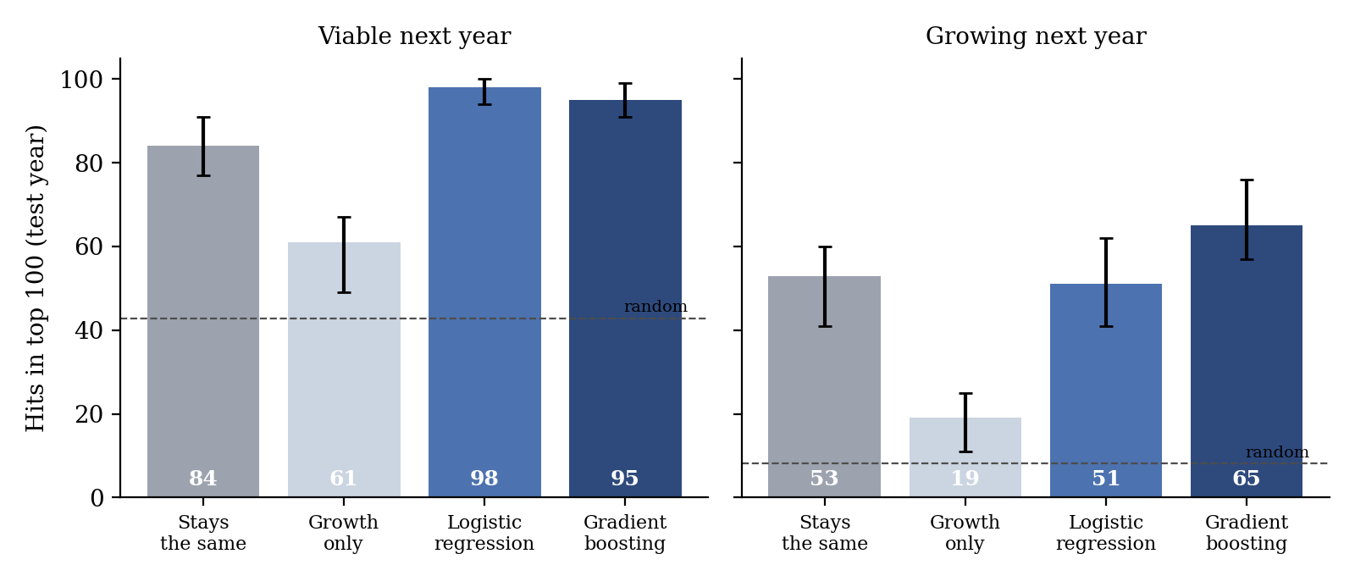
Fig. 3. Brands among each method's top 100 that were viable (left) or growing (right) a year later, test transition 2024 to 2025. Error bars show 95% bootstrap intervals; dashed lines show the base rate.
5.5 What the Models Rely On

One input dominated each model. For viability, the share of peak store coverage a brand retained was the most important input to gradient boosting and carried the largest logistic coefficient. For growth, sales relative to the brand’s best was the dominant input. Momentum had little effect on overall ranking but improved the top of the growth list in development. Prior-year sales growth contributed little to either model once the labeling ratios were included.

5.6 Results by Category

Figure 4 counts how many of each category’s ten highest ranked brands met the target a year later. For viability, the logistic model placed between 7 and 10 viable brands in the top ten of every category. For growth, results varied: 10 of 10 in Category A and 9 in Category D, but 5 in Category B and only 2 or 3 in Categories G, I, and J. Survivability identification is consistently screened across categories but finding growing brands is much more reliable in some categories than in others.

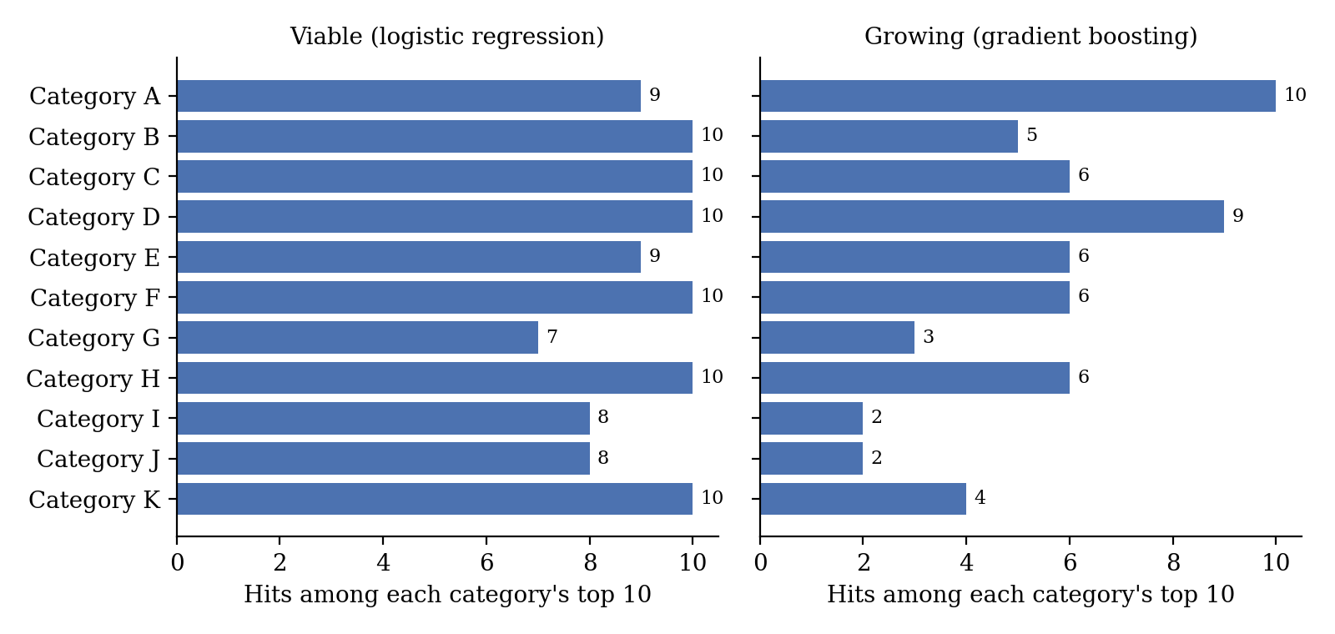
Fig. 4. Brands among each category's top 10 that were viable (left, logistic regression) or growing (right, gradient boosting) a year later, test transition 2024 to 2025.
6 Discussion

Three ratios and ordered rules reproduced the expert’s labels closely enough to replace hand labeling for generic use, with each label carrying an explanation that can be checked by an analyst. This changes what the framework can do. Labels are no longer limited to 112 brands in one category and in one time-frame. The rules also make the expert’s implicit standard explicit.
The prediction results separate an easy question and a hard one. Survival is predictable which is consistent with the literature distribution to sales [8]. A brand that has kept their shelf space tends to keep selling. Growth is a less persistent condition and the best model improved on the baseline modestly.
For the industry partner, the results support a ranked list of brands, ordered by the probability of growth and filtered by the probability of remaining viable. The category results caution against treating the list as equally reliable across categories, which is consistent with category conditions shaping brand trajectories [10] and motivates the category-context criterion proposed by the original study [2].

7 Ethics

The data were provided under a nondisclosure agreement that prohibits disclosure to third parties. The data were excluded from version control and are reported here only in aggregate with coded categories and no brand names. The industry partner is not named in the analysis outputs.
Automating an expert’s judgement also automates their assumptions. The rules encode one person’s view, formed on one category of what decline and growth look like, and applying them on a scale extends that view to thousands of brands. Providing a reason with every label, reporting agreement honestly, and publishing the thresholds allow users to question individual labels. A screening model also shapes what receives attention with the smallest extensions excluded from consideration.
The study’s purpose is to help a business grow sales of a product with well-documented public health costs. The analysis does not target consumers or marketing, but readers should recognize that improved commercial screening contributes to sales performance. Generative AI tools were used for code assistance and literature search. All analysis decisions and interpretations of the results are the authors’ own.

8 Limitations and Future Work
9 Conclusion

This study shows that an expert’s four-tier brand labels can be reproduced by three ratios and ordered rules, extending a 112 hand labeled set to other brands across 11 categories. The rules agree with the expert on 90.2% of tiers in sample and behave consistently across categories. With these labels, a simple logistic model identifies brands that will remain viable a year later.
References
1. Victory, K., Tanusondjaja, A., Dawes, J., Romaniuk, J., & Nenycz-Thiel, M. (n.d.). How do new products perform? An investigation [Manuscript]. SSRN. https://ssrn.com/abstract=4137036

2. Henderson, K., & Sadler, B. (n.d.). A decision framework for identifying high-potential emerging consumer-packaged goods brands [Manuscript]. Southern Methodist University.

3. Fildes, R., Ma, S., & Kolassa, S. (2022). Retail forecasting: Research and practice. International Journal of Forecasting, 38, 1283-1318. https://doi.org/10.1016/j.ijforecast.2019.06.004

4. Arora, T., Chandna, R., Conant, S., Sadler, B., & Slater, R. (2020). Demand forecasting in wholesale alcohol distribution: An ensemble approach. SMU Data Science Review, 3(1), Article 7. https://scholar.smu.edu/datasciencereview/vol3/iss1/7

5. Jiang, L., Rollins, K. M., Ludlow, M., & Sadler, B. (2020). Demand forecasting for alcoholic beverage distribution. SMU Data Science Review, 3(1), Article 5. https://scholar.smu.edu/datasciencereview/vol3/iss1/5

6. Ford, J., Nava, C., Tan, J., & Sadler, B. (2020). Automated machine learning framework for demand forecasting in wholesale beverage alcohol distribution. SMU Data Science Review, 3(3), Article 7. https://scholar.smu.edu/datasciencereview/vol3/iss3/7

7. Hirche, M., Farris, P. W., Greenacre, L., Quan, Y., & Wei, S. (2021). Predicting under- and overperforming SKUs within the distribution-market share relationship. Journal of Retailing, 97(4), 697-714. https://doi.org/10.1016/j.jretai.2021.04.002

8. Michis, A. A. (2023). Retail distribution evaluation in brand-level sales response models. Journal of Marketing Analytics, 11, 366-378. https://doi.org/10.1057/s41270-022-00165-8

9. Bronnenberg, B. J., & Sismeiro, C. (2002). Using multimarket data to predict brand performance in markets for which no or poor data exist. Journal of Marketing Research, 39(1), 1-17.

10. Dunn, S., Nenycz-Thiel, M., Graham, C., Dawes, J., Danenberg, N., Tanusondjaja, A., Trinh, G., & McColl, B. (2025). How categories grow: The behavioural drivers of revenue growth. Journal of Business Research, 195, Article 115385. https://doi.org/10.1016/j.jbusres.2025.115385

11. Ulrich, M., Jahnke, H., Langrock, R., Pesch, R., & Senge, R. (2022). Classification-based model selection in retail demand forecasting. International Journal of Forecasting, 38, 209-223. https://doi.org/10.1016/j.ijforecast.2021.05.010

12. Lam, P., Nguyen, H.-L., Nguyen, T.-T., Nguyen, S., & Vo, H. D. (2026). Structured exploration and exploitation of label functions for automated data annotation. Knowledge-Based Systems, 342, Article 115843. https://doi.org/10.1016/j.knosys.2026.115843

13. Zhu, X., Ninh, A., Zhao, H., & Liu, Z. (2021). Demand forecasting with supply-chain information and machine learning: Evidence in the pharmaceutical industry. Production and Operations Management, 30(9), 3231-3252. https://doi.org/10.1111/poms.13426

14. Lei, D., Qi, Y., Liu, S., Geng, D., Zhang, J., Hu, H., & Shen, Z.-J. M. (2025). Pooling and boosting for demand prediction in retail: A transfer learning approach. Manufacturing & Service Operations Management, 27(6), 1779-1794. https://doi.org/10.1287/msom.2022.0453

15. Kumar, N., Dheenadayalan, K., Reddy, S., & Kulkarni, S. (2022). Multimodal neural network for demand forecasting. arXiv. https://arxiv.org/abs/2210.11502

16. Pozner, J.-E., DeSoucey, M., Verhaal, J. C., & Sikavica, K. (2022). Watered down: Market growth, authenticity, and evaluation in craft beer. Organization Studies, 43(3), 321-345. https://doi.org/10.1177/0170840621993236

17. Kaufman, S., Rosset, S., Perlich, C., & Stitelman, O. (2012). Leakage in data mining: Formulation, detection, and avoidance. ACM Transactions on Knowledge Discovery from Data, 6(4), Article 15. https://doi.org/10.1145/2382577.2382579

18. Tashman, L. J. (2000). Out-of-sample tests of forecasting accuracy: An analysis and review. International Journal of Forecasting, 16(4), 437-450. https://doi.org/10.1016/S0169-2070(00)00065-0

19. Saito, T., & Rehmsmeier, M. (2015). The precision-recall plot is more informative than the ROC plot when evaluating binary classifiers on imbalanced datasets. PLOS ONE, 10(3), Article e0118432. https://doi.org/10.1371/journal.pone.0118432

